Distributed Task Scheduler

Submitted By

Ahsanur Rahman Nakib
0242310005101611

MINI LAB PROJECT REPORT
This Report Presented in Partial Fulfillment of the course
CSE324: Operating System Lab in the
Computer Science and Engineering Department


DAFFODIL INTERNATIONAL UNIVERSITY Dhaka, Bangladesh
December 14 , 2025

DECLARATION
We hereby declare that this lab project has been done by us under the supervision of Md Mehefujur
Rahman Mubin, Lecturer, Department of Computer Science and Engineering, Daffodil International University. We also declare that neither this project nor any part of this project has been submitted elsewhere as lab projects.

Submitted To:
Md Mehefujur Rahman Mubin,
Lecturer
Department of Computer Science and Engineering Daffodil International University.

i

COURSE & PROGRAM OUTCOME

The following course have course outcomes as following:

Table 1: Course Outcome Statements
CO’s | Statements
CO1 | Define and analyze task scheduling concepts and system resources
CO2 | Apply operating system scheduling algorithms in problem solving
CO3 | Analyze system behavior using priority-based scheduling
CO4 | Design and implement a real-world scheduling solution

Table 2: Mapping of CO, PO, Blooms, KP and CEP
CO | PO | Blooms | KP | CEP
CO1 | PO1 | C1, C2 | KP3 | EP1
CO2 | PO2 | C3 | KP3 | EP1, EP3
CO3 | PO3 | C4 | KP4 | EP2
CO4 | PO3 | C6 | KP4 | EP3

The mapping justification of this table is provided in section 4.3.1, 4.3.2 and 4.3.3.
ii
Table of Contents

Declaration i
Course & Program Outcome ii
1 Introduction 1
1.1 Introduction 1
1.2 Motivation 1
1.3 Objectives 1
1.4 Feasibility Study 1
1.5 Gap Analysis 2
1.6 Project Outcome 2
2 Proposed Methodology/Architecture 3
2.1 Requirement Analysis & Design Specification 3
2.1.1 Overview 3
2.1.2 Proposed Methodology/ System Design 3
2.1.3 UI Design 4
2.2 Overall Project Plan 4
3 Implementation and Results 5
3.1 Implementation 5
3.2 Performance Analysis 5
3.3 Results and Discussion 5
4 Engineering Standards and Mapping 6
4.1 Impact on Society, Environment and Sustainability 6
4.2 Project Management and Team Work 6
4.3 Complex Engineering Problem 6
4.3.1 Mapping of Program Outcome 6
4.3.2 Complex Problem Solving 7
4.3.3 Engineering Activities 7
5 Conclusion 8
5.1 Summary 8
5.2 Limitation 8
5.3 Future Work 8

6 References 8

iii

1 Introduction
This chapter presents an overview of the project, including background, motivation, objectives, feasibility, gap analysis, and expected outcomes.

1.1 Introduction
In modern computing systems, executing multiple tasks concurrently is a fundamental requirement. Operating systems manage this process through task scheduling mechanisms. This project implements a Distributed Task Scheduler that simulates how tasks are scheduled based on priority, CPU usage, memory requirements, storage availability, and execution time.

1.2 Motivation
Task scheduling plays a vital role in operating systems such as Linux and Windows. The main motivations behind this project are:
- To understand operating system scheduling concepts practically
- To learn how preemptive priority scheduling works
- To gain hands-on experience with resource management and concurrency

1.3 Objectives
Task scheduling plays a vital role in operating systems such as Linux and Windows. The main motivations behind this project are:
- To understand operating system scheduling concepts practically
- To learn how preemptive priority scheduling works
- To gain hands-on experience with resource management and concurrency

1.4 Feasibility Study
Modern operating systems use advanced scheduling algorithms to manage processes efficiently.
This project is feasible as it is implemented using Python, threading, and priority queues, which are well-suited for simulating concurrent task scheduling behavior.

1.5 Gap Analysis
Most academic scheduling examples are static and theoretical.
This project bridges the gap by introducing:
- Dynamic task arrival
- Real-time task execution and preemption
- Practical resource constraint handling

1.6 Project Outcome

The outcome of this project is a fully functional Distributed Task Scheduler Simulation that demonstrates real-world operating system scheduling behavior in an educational environment.

2 Proposed Methodology/Architecture
This chapter describes the system requirements, architecture, and design methodology.

2.1 Requirement Analysis & Design Specification
The following requirements are necessary to develop the system:
- Python Programming Language
- Threading and Synchronization Mechanisms
- Priority Queue (Heap)
- Command-Line Interface (CLI)

2.1.1 Overview
The system architecture consists of three major components:
- Running Tasks
- Ready Queue
- Resource Manager (CPU, RAM, Storage)

2.1.2 Proposed Methodology/ System Design
Figure 2.1: This is a sample diagram
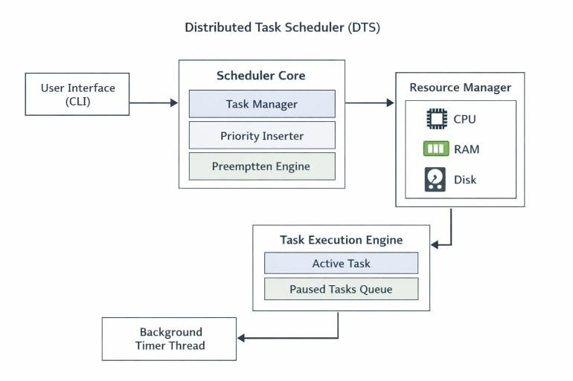

2.1.3 UI Design
The user interface is terminal-based and displays:
- Current running tasks
- Ready queue tasks
- Available system resources

2.2 Overall Project Plan
The project was completed in the following phases:
- Problem Analysis
- System Design
- Implementation
- Testing
- Documentation

3 Implementation and Results
The system is implemented using Python threading, priority queues, and synchronization mechanisms to manage concurrent task execution efficiently. Performance analysis shows that high-priority tasks are executed promptly while minimizing resource starvation and maintaining system stability.

3.1 Implementation
The system is implemented using Python threading to handle concurrent task execution.
A priority queue is used to manage the ready queue, ensuring that higherpriority tasks are scheduled first.

3.2 Performance Analysis

Higher-priority tasks are executed with minimal delay
System resources are utilized efficiently
The scheduler maintains system stability under multiple tasks

3.3 Results and Discussion
The results demonstrate that the scheduler effectively mimics real operating system behavior, including preemption, priority handling, and resource management.
Chapter 4

Engineering Standards and Mapping
This chapter evaluates project’s engineering standards, emphasizing sustainability, social impact, and ethical considerations.It also maps the project outcomes to DIU program outcomes, demonstrating structured problem-solving and engineering practices.

4.1 Impact on Society, Environment and Sustainability
Efficient task scheduling improves system performance and reduces energy consumption, contributing to sustainable computing practices.

4.2 Project Management and Team Work
The project was completed individually using proper planning, time management, and systematic development practices.

4.3 Complex Engineering Problem
This project addresses complex engineering challenges such as:
- Concurrent task execution
- Resource conflicts
- Priority-based decision making.These characteristics qualify it as a complex engineering problem.

4.3.1 Mapping of Program Outcome
In this section, provide a mapping of the problem and provided solution with targeted Program Outcomes (PO’s).

Table 4.1: Justification of Program Outcomes
PO’s | Justification
PO1 | Applied OS concepts and scheduling theory
PO2 | Analyzed task conflicts and resource limits
PO3 | Designed and implemented scheduler
P04 | Investigated performance behavior

4.3.2 Complex Problem Solving

In this section, provide a mapping with problem solving categories. For each mapping add subsections to put rationale (Use Table 4.2). For P1, you need to put another mapping with knowledge profile and rational thereof.
Table 4.2: Mapping with complex problem solving.
EP1  Dept of  Knowledge | EP2  Range of  Conflicting  Requiremen  ts | EP3 Depth of  Analysis | EP4  Familiarity of Issues | EP5  Extent of  Applicable Codes | EP6  Extent  Of  Stakeholder  Involvement | EP7  Inter-  dependence
✔ | ✔ | ✔

4.3.3 Engineering Activities
In this section, provide a mapping with engineering activities. For each mapping add subsections to put rationale (Use Table 4.3).

Table 4.3: Mapping with complex engineering activities.
EA1  Range of resources | EA2  Level of Interaction | EA3 Innovation | EA4  Consequences for society and environment | EA5  Familiarity
✔ | ✔ | ✔
Chapter 5

Conclusion
The project successfully develops a Distributed Task Scheduler that simulates priority-based and preemptive scheduling techniques.Although effective, the system is limited to simulation and operates through a command-line interface without real hardware control.Future improvements may include a graphical interface, real-time performance visualization, and network-based distributed scheduling.

5.1 Summary
This project successfully implements a Distributed Task Scheduler that simulates prioritybased and preemptive scheduling techniques.

5.2 Limitation

The system is a simulation and does not control real hardware
The scheduler is limited to a command-line interface

5.3 Future Work
Future enhancements may include:
- Graphical User Interface (GUI)
- Real-time performance visualization
- Network-based distributed task scheduling

Reference

[1] Jon Kleinberg and Eva Tardos, Algorithm Design, Pearson Education

